March 23, 2016  at  Cobb Galleria Centre  Two Galleria Parkway  Atlanta, Georgia 30339 | 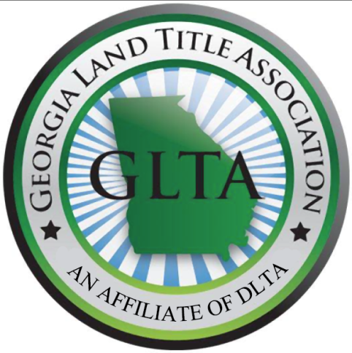 | SPECIAL THANKS  TO OUR SPONSORS:  Simplifile  SoftPro  PYA  Frazier & Deeter  Carr, Riggs & Ingram, LLC  E-Closing

The Education Committee of the
Georgia Land Title Association, LLC
Presents:

SPRING 2016 SEMINAR
6.0 Hours of CLE Credit including 1 Hour of Professionalism (GA)
AL DO ICE Credits pending approval

FEATURING:
U.S. Senator
Johnny Isakson
Register ONLINE for Seminar/CLE with Buffet Lunch included

REGISTER ONLINE at www.DLTA.net

Please bring a jacket or sweater as the room may be cooler in the morning.

Seminar and Lunch

DLTA MEMBERS $120.00*– ADD $30.00 FOR CLE CREDIT

NON-DLTA MEMBERS $170.00* – ADD $30.00 FOR CLE CREDIT

IF SENDING A CHECK: DIXIE LAND TITLE ASSOCIATION, INC.
Linda Alwood, Executive Director
Dixie Land Title Association
P.O. Box 14806
Baton Rouge, LA 70898

QUESTIONS? CALL OR E-MAIL: Amanda Calloway
Phone 678-406-8918 Email amandac@titlelaw.com
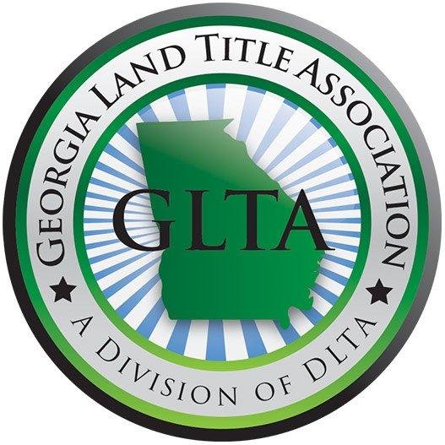

SPRING 2016 AGENDA March 23, 2016

7:45 Registration Opens

8:20 Welcome Remarks: Amanda Calloway, Esq.
Education Committee Chairperson

8:30-9:30 New ALTA Survey Standards
Mark Chastain
Chastain & Associates, P.C

9:30-10:30 Business Entities and Title To Property
Clyde Mize, Esq.
Morris, Manning & Martin, LLP

10:30-11:00 Washington Update
Senator Johnny Isakson
United States Senator

11:00 15 Minute Break

11:15-12:15 Professionalism
Carol V. Clark, Esq.
Carol Clark Law

12:15 Lunch

1:15-2:15 Title Claims
Tenise A. Cook, Esq.
Rubin Lublin, LLC

2:15 15 Minute Break

2:30-3:30 Deed Attestation and Recent Changes Affecting Real Estate Practice
Debora Bailey, Esq.
Gilroy Bailey Trumble LLC

3:30-4:00 Alluring Appeals - Current Cases in our Appellate Courts Which Impact your Practice
Monica Gilory, Esq.
Gilroy Bailey Trumble LLC

REGISTRATION FOR GEORGIA TITLE SCHOOL
March 23, 2016 AT THE COBB GALLERIA CENTRE
First Name:____________________________________

Middle Initial:__________________________________

Last Name:____________________________________

Company:_____________________________________

Bar Number:___________________________________

Address:_________________________________
_________________________________
_________________________________

Email:________________________________________
Phone:_______________________________________
GLTA is going GREEN. Materials will be emailed to all attendees several days before the seminar. Hard Copies will also be available on the day of the seminar

REGISTER ONLINE AT WWW.DLTA.NET OR BY MAIL
Amount of Check Enclosed:
____ $120 (DLTA member, no CLE credit)
____ $150 (DLTA member, include CLE credit)
____$170 (Non-DLTA member, no CLE credit)
____$200 (Non-DLTA member, include CLE credit)
Please mail check and registration to: DIXIE LAND TITLE ASSOCIATION, INC.
Linda Alwood, Executive Director
Dixie Land Title Association
P.O. Box 14806
Baton Rouge, LA 70898

