HOTELS IN ATLANTA
(within a ½ mile radius of the State Bar)

The Omni https://www.omnihotels.com/hotels/atlanta-cnn-center
Home to Home Suites http://home2suites3.hilton.com/en/hotels/georgia/home2-suites-by-hilton-atlanta-downtown-ATLDWHT/index.html
Twelve Centennial Park http://twelvehotels.com/twelve-hotels-centennial-park/
The Westin http://www.westinpeachtreeplazaatlanta.com/
Embassy Suites http://embassysuites3.hilton.com/en/hotels/georgia/embassy-suites-by-hilton-atlanta-at-centennial-olympic-park-ATLESES/index.html
The Glenn Hotel http://glennhotel.com/
Hilton Garden Inn http://hiltongardeninn3.hilton.com/en/hotels/georgia/hilton-garden-inn-atlanta-downtown-ATLDOGI/index.html
Doubletree http://doubletree3.hilton.com/en/hotels/georgia/doubletree-by-hilton-hotel-atlanta-downtown-ATLSSDT/index.html
Hampton Inn http://hamptoninn3.hilton.com/en/hotels/georgia/hampton-inn-and-suites-atlanta-downtown-ATLHSHX/index.html
Holiday Inn Express https://www.ihg.com/holidayinnexpress/hotels/us/en/atlanta/atlws/hoteldetail?cm_mmc=YextLocal-_-USA-_-ATLWS
Courtyard by Marriott http://www.marriott.com/hotels/travel/atldo-courtyard-atlanta-downtown/
Residence Inn http://www.marriott.com/hotels/travel/atldt-residence-inn-atlanta-downtown/
The Ellis http://www.ellishotel.com/
Fairfield Inn http://www.marriott.com/hotels/travel/atlus-fairfield-inn-and-suites-atlanta-downtown/
Aloft http://www.aloftatlantadowntown.com/
Hyatt House https://atlantadowntown.house.hyatt.com/en/hotel/home.html
The W http://www.watlantadowntown.com/
Hotel Indigo https://www.ihg.com/hotelindigo/hotels/us/en/atlanta/atlid/hoteldetail
The Ritz http://www.ritzcarlton.com/en/hotels/georgia/atlanta
The Hyatt Regency https://atlanta.regency.hyatt.com/en/hotel/home.html

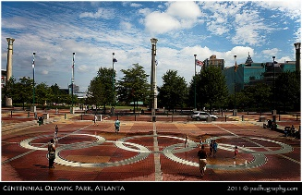
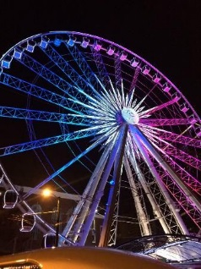
PLACES TO VISIT
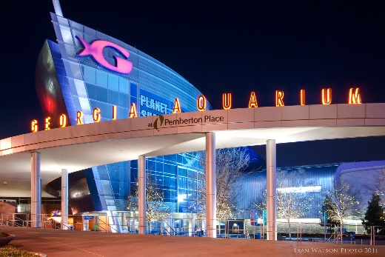
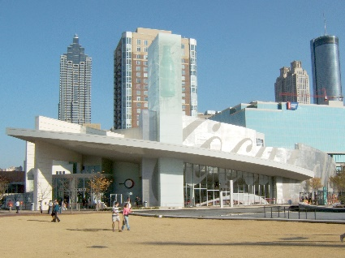
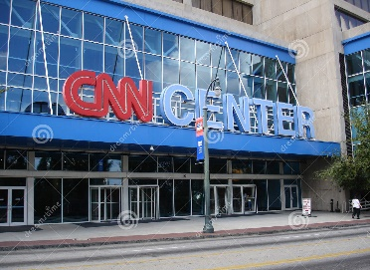

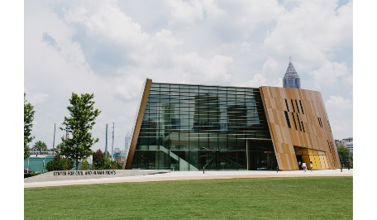
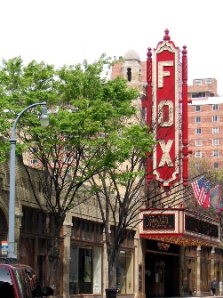
DOWNTOWN
Centennial Olympic Park
Georgia Aquarium
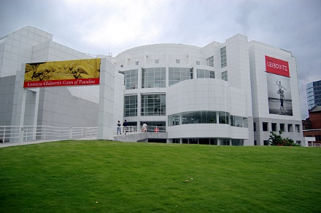
World of Coke
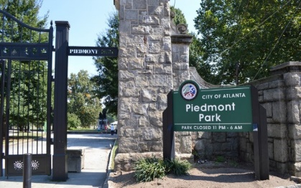
Skyview Ferris Wheel
CNN Center
Center for Civil and Human Rights
ATLANTIC STATION
Bodies: The Exhibition
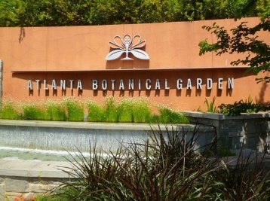
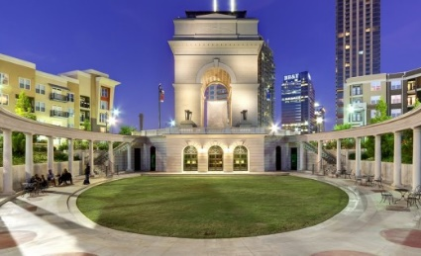
Millennium Gate Museum
MIDTOWN
Fox Theater
Atlanta Botanical Garden
Piedmont Park
The High Museum of Art
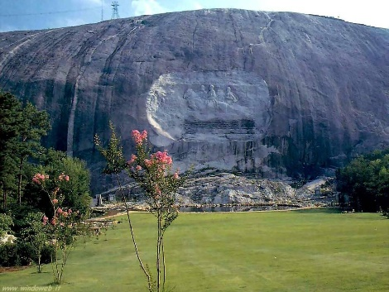
VARIOUS NEIGHBORHOODS AROUND ATLANTA
Escape Rooms (Downtown and various)
The Carter Center (Poncey Highlands)
Ponce City Market (Old Fourth Ward)
Zoo Atlanta (Grant Park)
Oakland Cemetery (Cabbagetown/Grant Park)
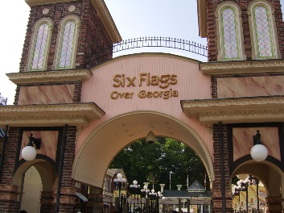
Fernbank Museum of Natural History (Decatur)
Movie and Television Tours (Various locations)
Atlanta Beltline (Around Atlanta)
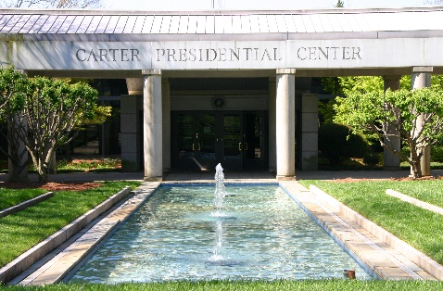
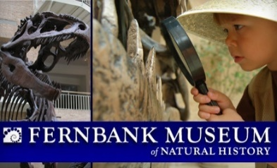
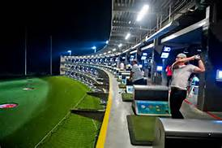
Top Golf (Westside/Midtown)
Six Flags over Georgia (I-20 towards Alabama)
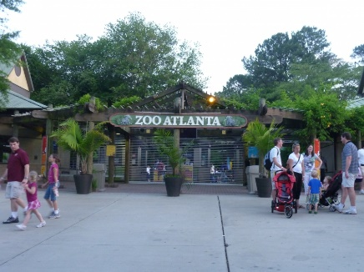
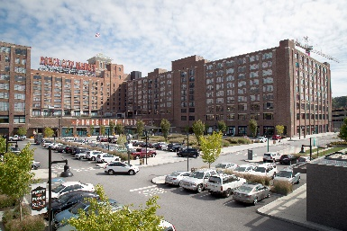
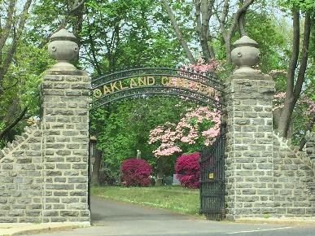
Stone Mountain (Stone Mountain, Georgia)

